Nursery rhyme ‘stay and play’
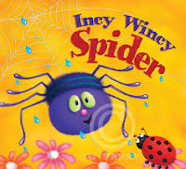
You are invited to join us in the
Caterpillar’s class on
Thursday 4th May at 11am
for lots of fun with your child.
We look forward to seeing you then!

____________________________________________________________________

Child’s name ________________________________________________

I will attend the session from 11am-11.30am

I enclose a contribution of £1 towards resources

