Dear Parents/Carers,
We have an exciting day trip! Would you and your child like to visit the
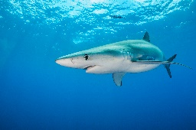 Blue Planet Aquarium? 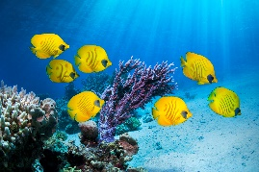
We have organised a free trip travelling by coach on Wednesday November 1st. You may bring a booster seat for your child to use on the coach if you wish.
Coaches will depart from just outside Aldi on Nantwich Road at 9.30am and we will return between 2.15pm-2.30pm. This will allow us approximately 3 hours at the aquarium as coaches will depart at 1.30pm to return to Crewe.
Each child can be accompanied by one adult. You can either bring a packed lunch with you or buy your own lunch in the café.
Our trip is kindly funded by Beechwood Hall Trust and Westminster Nursery Fundraising.
We need confirmation of numbers as soon as possible. We are looking forward to a lovely family day out.
……………………………………………………………………………………………………………………………………………………….
Blue Planet Aquarium
Child’s Name ……………………………………………………………………………… will be attending the trip on Wednesday November 1st.
An adult will / will not be attending this trip with my child.

Signed……………………………………………………………………
Relationship to child ………………………………………
Date………………………………………

