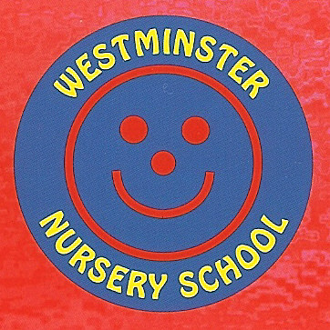
2022-2023 Autumn Term EYPP
In 2022-23 there are 4 children eligible for EYPP. Children with entitlement are awarded £0.60p per hour additional funding. This equates to £342 per EYPP eligible pupil over a full school year.
The money is to be spent as per the following table, and impact will be monitored through keyworkers assessments and pupils’ well-being.
Focus areas to meet our EYPP pupil’s needs:
- Communication and Language – Delayed language development, impact of EAL, all aspects of CL, most particularly speaking, listening attention and understanding. Use of SALT plans with individual children. Extending communication for more able.
- Self-help skills – Support with toilet training, to be independent with clothes such as coats and to gain confidence in social situations - self –confidence building activities, nurture group and keyworker support.
- Reading – development of language and low-level book skills, lack of English provides a barrier.
- Building relationships and developing self - regulation – Ensuring engagement with others and ability to develop relationships including understanding of feelings. Developing confidence in play. This links across all areas of development. This area includes our nurture, self-confidence groups.
- Home school links – keyworkers sharing parenting strategies to support child development and aid parents understanding of child’s next steps.
- Fine motor skills - developing pincer grip and additional control in small movements

Intent: | Implementation: | Cost | Impact: | Evidenced through:
Building Relationships and self-regulation development  Targeted group work and activities to support with nurture around emotional needs and understanding emotions. | TA time 2 x weekly intervention  All EYPP children requiring nurture and circle time support – keyworker support  Equipment including texts bought to support this area | £126 | Children’s well- being is improved, confidence is raised.  In class time support given to specific children  Understanding of emotions vocabulary promoted | Key worker knowledge shows improvement  Pupil Progress tracking  Progress evident in children’s learning records
Communication and Language  SALT care plans  vocabulary and listening and attention intervention groups. | TA time 0.5 hours per week SALT  Vocab group 3 x weekly  Listening and attention group 2 x weekly | £180 | Speech monitored from baseline, regularly to track progress.  Extend and challenge at appropriate level to ensure highest outcomes for all.  WELLCOMM levels raised at termly assessment.  Vocabulary and language skills raised | Pupil progress tracking  Records of interventions kept  Progress evident in children’s learning records
Reading development of language and low-level book skills, lack of English provides a barrier | Key worker time in daily provision | £50 | Child can understand and benefit from sharing and reading books with an adult support. Language development seen. | Records of interventions kept  Progress evident in children’s learning records  keyworker knowledge and daily 1:1 story
Self-help skills Children are supported by to develop skills of independence including clothes, confidence building and toilet training. | Daily activities in key worker groups | £50 | Children join in with group activities as understanding and listening/attention improve. | Overall levels improve across all subjects.  Children’s self-esteem and independence skills improve
Fine motor control | Play based activities in provision | £50 | Children strengthen hand muscles and develop pincer grip | Greater skill in handling and controlling small objects including writing tools and scissors as seen in children’s learning records.

Next review March 2023

