

What we do in Nursery…
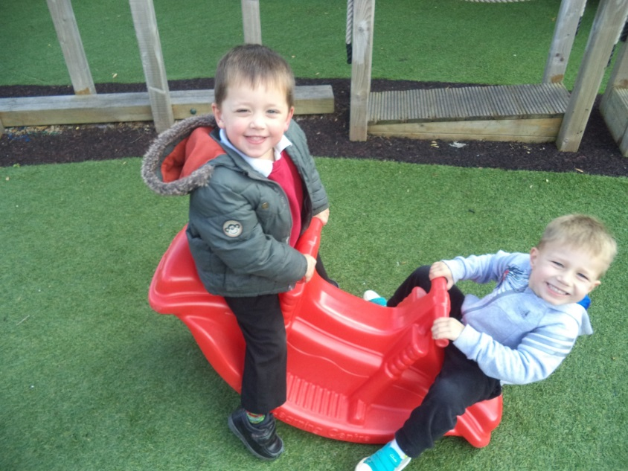
We aim to provide a safe, inspiring and learning environment, working closely with parents and families.

Head Teacher: Mrs E.M Hulse
Nursery Lead Teacher: Mrs E Connor/Miss L Barlow
Telephone: 01270 560319
Email: head@westminster.cheshire.sch.uk
Email: admin@westminster.cheshire.sch.uk
Website: www.westminster.net

Parents as Partners

Children are learning from the day they are born. When a child begins nursery, parents and nursery staff become partners in the learning process. Up until now, you have been your child’s first teacher; together we can take your child to the next step.

This is a very important stage as it helps your child get ready for school as well as preparing them for their future learning and successes. From when your child is born up until the age of 5, their early years experience should be happy, active, exciting, fun and secure; and support their development, care and learning needs.

Learning in the Early Years

The Early Years Framework explains how and what your child will be learning to support their healthy development. Your child will be learning skills, acquiring new knowledge and demonstrating their understanding through 7 areas of learning and development.

Children mostly develop the 3 prime areas first:

- Communication and language;
- Physical development;
- Personal, social and emotional development.

These prime areas are those most essential for your child’s healthy development and future learning. As children grow, the prime areas will help them to develop skills in 4 specific areas:

- Literacy;
- Mathematics;
- Understanding the world; and
- Expressive arts and design.

These 7 areas are used to plan your child’s learning and activities. This is a little bit like a curriculum in primary schools, but it's suitable for very young children, and it's designed to be really flexible so that staff can follow your child's unique needs and interests.

Children in the EYFS learn by playing and exploring, being active, and through creative and critical thinking which takes place both indoors and outside.

 | Westminster  Nursery Rules    Nursery rules help everyone to be safe and happy in our nursery.  We hope you will talk about these at home with your child.
  1. Be kind and share
  2. Listen carefully
  3.Walk to stay safe
  4.Take care of our toys

Westminster Nursery School
Daily Routine for Butterflies AM/PM

(3 year old room)
Times (approximate) | Activity
8.30- 8.55  12.30- 12.45 | Welcome, self-registration,  choose activity  Breakfast Club AM | 
8.55-9.10  12.45 – 1.00 | Group Time:  Welcome, calendar, activity | 
9.10  1.00 | Key Worker group activity  free flow CI Time | 
10.15  2.15 | Group Time – Language & Phonics | 
10.30  2.30 | Snack and chat | 
10.40  2.40 | Free flow CI time, outdoor play | 
11.10  3.10 | Tidy up time | 
11.20  3.20 | Carpet, songs/story | 
11.30  3.30 | Home time | 

30 hour Children will follow these times with a variation of learning opportunities
during the day.

If you would like further details of the Early Years Framework please visit our school website which includes additional documentation or the Foundation Years website – www.foundationyears.org.uk

Nursery Staff
Mrs Elizabeth Hulse | Head Teacher (Key worker)
Mrs Emma Connor/Miss Louise Barlow | Lead Teacher(Key worker)
Miss Layla Tudor | Teaching Assistant(Key worker)
Mrs Beata Gluchowska | Teaching Assistant(Key worker)
Mrs Julie Bell | Teaching Assistant(Speech & Language)
Mrs Amanda Sides | Teaching Assistant
Miss Sophie Quinn-Jones | Teaching Assistant
Mr Neil Smith | Admin Officer
Mrs Karen Sarson | Caretaker
Mrs Mylene Booth | Mid-day Assistant
Miss Ruby Smith | Apprentice

All of the teaching staff are key persons and work with a ratio of 13 children to 1 adult in the 3 year old nursery and 4:1 in the 2 year old nursery. Children are assigned to a key person group when they begin nursery, although all staff get to know and work with all children.

Website http://www.westminsternurseryschool.net/
Our nursery website is kept up to date with regular blogs about the activities the children have been doing. We love to hear your comments so please keep your eye on it and respond – it’s a great way of keeping in touch.

Nursery Opening Times

Before School Club 8.00am – 8.30am
Morning Session: 8.30 am – 11.30 am
Lunch club 11.30am – 12.30pm
Afternoon Session: 12.30 pm – 3.30 pm
Please ensure that your child is collected promptly at the end of a session. As you can
see, we have only a short time between sessions to set up for the afternoon and eat! At
the end of the day, we often have meetings to attend.

However, we do understand that situations may arise but please ensure you notify us if
you are going to be late to collect your child.

Attendance

It is very important that your child attends as regularly as possible. Past experience and
progress analysis tells us that when children do not attend regularly their progress
can be hindered. Obviously there are times when your child needs to be absent and
we fully understand. Whenever your child is absent from nursery we would appreciate
it if you could telephone us on the first day of absence to let us know. If we do not hear
we will try to contact you.

Settling in

All children will be offered a home visit prior to starting nursery. This allows your child
to meet their 2 members of staff in their own environment. Following some settling in
sessions, your child will be admitted to nursery.

Every child is unique – each one adjusts to the new environment in their own special way;
some take longer than others. Staff are always available to comfort your child if they
are upset. Often children are upset for a very short time. In instances where a child
becomes very distressed, staff will contact you by telephone and ask you to return.
Depending upon how your child adjusts to the new routine of coming to nursery, your
child’s key worker will advise you about the next step. This may be for your child to
attend nursery for the full 3 hours or for a reduced time – you and your child will be our
guide. When it is time to leave your child, always remember to say goodbye and inform a
member of staff that you are going. Parents/Carers are welcome to wait in the Family
Room, have a coffee and meet other new parents.


Westminster Nursery School
Daily Routine for Caterpillars
(2 year old room)
Times (approximate) | Activity
8.30- 9.00 | Welcome, settle, stay and play (visual nappy check)  Toast/drink | 
9.00-9.10 | Hello, weather, whole group activity | 
9.1 | Key Worker group activity and free flow CI Time inside and outside | 
10.15 | Care routines (nappy changing/potty changing/toilet) | 
10.25 | Tidy time | 
10.30 | Snack and chat | 
10.45 | Free flow CI time, outdoor play | 
11.20 | Carpet, songs/story | 
11.30 | Home time, sign out | 

Worries and Concerns

Should you have any worries or concerns about your child please discuss them with your
child’s key person who will be happy to help. If we have any concerns about
your child’s development, we will speak with you before involving any other specialists.
Sometimes it is necessary to involve other people such as speech therapist, psychologist,
health visitor, specialist teacher and so on. We have our own speech and language
teaching assistant, Miss Julie Bell, who works with children , often on targets set by the
SALT team. The school has a Special Educational Needs Co-ordinator (SENCO) who is
also able to offer advice and guidance.

Head Teacher

The Head Teacher, Mrs Elizabeth Hulse is always happy to discuss any matters
which are important to you and your child. It may be necessary to make an appointment
at the school office.

Final Thoughts….

Finally, be assured that all the nursery staff will do their very best to enable your child to
flourish and have fun in their nursery surroundings. We are passionate about what we
do and totally committed to continuing to make Westminster Nursery School the best
early years provision it can possibly be. We look forward to getting to know your child,
you and your family whilst you child attends our school and you all become part of our wide
school family.

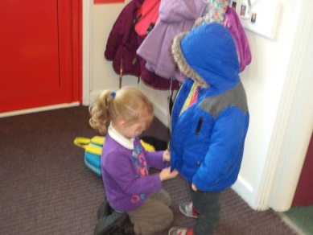
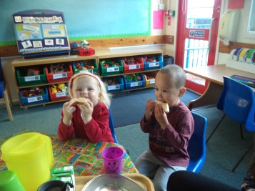

Collecting your Child

If there is someone different coming to collect your child, please let us know. If we are not sure who your child is to go home with, we will have to telephone you to make sure. Each room has a parental consent book in which we can record the name of a different person who might be collecting your child. Please let us know at drop off if this is the case.

Clothing

Our nursery is a very busy place with lots of activities going on. We encourage children to explore and enjoy the nursery environment as much as possible and that can get messy! We have paint, glue, sand, water and dough available nearly all the time, as well as freedom to explore the nursery grounds. These tactile experiences are all important for children’s development, but children will get messy or even dirty! We recommend that children wear older clothes or the school uniform that won’t matter if they get spoiled. On photograph days we always give advance warning and put our messy activities away for the day. Please also remember clothing and accessories need to reflect the weather; so wellington boots when it is raining and sun hats for summer. A change of clothes, left on your child’s peg is really useful.

Language Time
During the sessions we deliver language time related to Letters and Sounds: Phase One. Daily activities are planned within the Communication, Language and Literacy area of learning in the Early Years Foundation Stage and a language program called Wellcomm.
Through the session children are free to move throughout the nursery and take part in a wide variety of activities, both adult led and child initiated. Our outdoor area is available for the children to have the choice of either indoor or outdoor activities. We use the outdoor area all year round, even if raining, wet weather suits are available for additional protection as well as wellington boots.

Nursery Library
Every Thursday your child will have the opportunity to choose a book to take home, we hope
you will spend some time to read and look at it with your child as this will be part of the
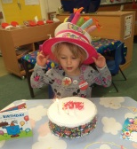
‘learning to read’ process that is so important.
Birthdays
We like to celebrate birthdays as a social event. We have a ‘pretend’ cake
with candles that we light and then sing ‘Happy Birthday’. Parents occasionally wish to send chocolate/sweets to share as a birthday treat, unfortunately due to an increasing number
of children with allergies, and our Healthy Eating policy, we are unable to give these out at nursery. Children may wish to give them out as the children leave the school with their
parents’ consent.

Indoor Activities
Certain areas of provision are available every day to the children. We also enhance these
areas by adding different resources to ensure they offer variety and continue to challenge
the children.

Book Area/Quiet Corner

Books are available for children to look at in all our story rooms but we also have a quiet
den where children can rest, relax and share a favourite book with a friend.

Mark Making and Fine Motor Skills/Finger Gym

This area has a ‘help yourself’ trolley where children can find lots of different mark making resources such as whiteboards, chalkboards, pens and pencils.
We also offer the children daily activities to help them develop the muscles in their hands
which they will need for writing such as threading and lacing, sensory play and dough.

Please ensure that your child’s name is written or sewn into any items of clothing that they are likely to take off – coats, jumpers, cardigans, gloves, hats, scarves. Sometimes items do go missing and we can get items back to you more easily if they are labelled. Occasionally children will put nursery toys in their pockets, the children are very young and this happens. It’s best to gently explain that nursery toys stay at nursery and then return things to us.

Accidents

Staff in the nursery protect the well-being of your child and adhere to the school’s Safeguarding Policy. In the event of illness or serious accident, every effort will be made to contact the child’s parents/carers. Significant accidents with be recorded and a slip given out to parents when they collect their child. Staff in both rooms hold a current First Aid qualification. It is very important that we have your most up-to-date telephone numbers. ( a minimum of 2 please) In the event that your child injures themselves at home, please let us know so that we can keep an eye on your child.

Toileting Accidents

The children in nursery are very young and accidents do happen sometimes. We do have a small selection of spare clothes, although many children prefer to have their own clothes. It is essential to bring spare clothes in a named bag and put it on your child’s peg.

Tracking your child’s progress

Your child will have a learning Journey book in which staff record the activities and achievements seen. We love parents to contribute to this and ‘wow moment’ slips are available in the entrance hall. The books in the Butterflies room are kept in baskets so that you can look at your child’s book when you like. We also ask parents to complete a slip once a term to stick in the book, saying how they feel about the contents.

On Arrival
Please help your child to hang up their coat and then bring them into the classroom to
their key worker. This is your child's 'special' teacher and she is responsible for
recording your child's arrival at nursery.
Encourage your child to find their name card and help them to choose an activity to go to
before you leave. This enables them to settle more easily and involves you in their daily
routine. Please be prepared to spend as much time as necessary initially, we want your
child to feel happy and secure otherwise no learning can take place.

Group Time followed by Snack and Chat time
Just before Group Time we play music to signal to the children it is ‘tidy up time’ and
encourage all children to be responsible for tidying the area in which they have been
working in.
Snack Money/School Fund

We offer toast, milk and water at the beginning of the morning session as it is an early
start for some families and children may not have time to have breakfast before
coming to Nursery. There is always a choice of fruit, vegetables, milk and water
available for snack.. We sometimes also have other foods such as toast, crumpets,
cheese, crackers, breadsticks etc. A voluntary contribution per week for each child is
£2.00, although it is possible to pay per half term or term if this is easier. Any additional
funds pay for other things such as new toys, equipment, dough ingredients, replenishing
books and special events such as having caterpillars to study etc.

Personal Belongings

Children in the Butterflies have their own trays, where they can keep their pictures and
creations whilst at nursery and any other bits and pieces such as pictures, gloves, hats
etc. We discourage children from bringing toys from home into nursery. These may get
lost or broken and we aim to avoid any distress caused by this. Please support us by reminding your child to keep personal toys at home.

Snack Time

Children are encouraged to share out the snack and have snack and chat time. Staff sit with the children and monitor to make sure everyone is offered a daily snack.

Construction/Small World Area

The children have a wide variety of construction materials such as Duplo and Mobilo which they can choose from. We also have large hollow blocks which develop the children’s creativity and encourage them to work together. The children can also access different props to support pretend play like cars, trains, zoo and farm animals.

Role Play

We are fortunate to have a large role play area where children can find lots of resources to help them act out familiar experiences from home with their friends. We also offer resources for themed role play.

Discovery Area

This area is where children can extend their knowledge and understanding of the natural world by helping to care for our nursery pets and plants. We also offer a range of natural materials for them to investigate.
Maths Area

We provide a range of maths resources for children such as blocks and shapes to make patterns with and a weekly maths challenge which allows children to apply the knowledge they have learnt in adult-led sessions. We also have lots of interesting objects for children to count, sort and order.

ICT

We are fortunate to have a touch screen in the 3 year old room which children can use. Each key person also has an iPad which the children can use under supervision.

Sand and Water

Sand and water play are always on offer to the children indoors and out. We also enhance
these areas using lots of different containers, funnels, jugs, moulds, sieves, natural
materials, boats, ducks etc.

Creative Area

Children can take part in planned creative activities such as printing as well as having access
to a range of art materials.

Outdoor Activities

The outdoors is not just an extension of the indoor learning environment! We aim to offer
the children a wide range of experiences on a different scale to those available indoors. We ensure that children are able to experience nature at first hand through different seasons
and weather conditions and observing plants, bugs and birds.

Physical Development

Children can exercise their physical skills such as balancing and climbing on our purpose-
built play equipment. We also have plenty of wheeled toys, many of which seat two to
encourage conversation! Children can also select from a wide variety of resources such as
bats, balls and hoops.

Mud Kitchen

This year we are hoping to gain some additional funding to develop a new mud kitchen. This
will help to support children’s creativity and problem solving skills.

Investigation Area

Children can access microscopes and magnifying glasses to investigate nature, use our large
scales to investigate weight or made sculptures using natural materials.
Maths is embedded throughout our outdoor area with resources to help children recognise numbers, count, sort or match.
Books/Quiet Areas

Children can take a moment to rest, relax or look at books in one of our quiet dens or watch the others playing from the vantage point of our wooden playhouse.

Music and Sensory Area

Here children can experiment with creating different sounds using our large musical instruments or free and found resources.

Mark Making Area

We have a large trolley where children can find a variety of clipboards, pens and chalks which they can take with them to the different areas. We also have large scale mark making resources which help to develop the muscles they need to write with.

Connor’s Corner/Nature Area

We are particularly fortunate to have an outdoor nature area and we are developing a storytelling area and herb garden, bug hotels are currently developing.

Construction Area

This area allows children the space to build on a large scale with lots of open-ended materials to choose from.
Nursery Books

We actively encourage children to be interested in books and develop a love of stories being read to them. Book bags are available to purchase from the school office, for transporting books to and from nursery and children are welcome to borrow nursery books to share at home.

