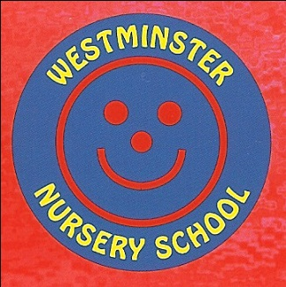

PSHE Policy (including SRE)

The school aims:

Personal development is an essential building block for all children.
Westminster Nursery School aims to deliver a curriculum which promotes children’s personal development through direct teaching, daily modelling, and discussion.
We understand the role the personal development curriculum has to play in keeping children safe and healthy.

Key areas of learning include:

- Ways to stay safe in school and at home, including crossing the road safely and how to dial emergency services.
- The importance of healthy food / drink choices, sleep and exercise
- Hygiene: bathroom use, handwashing, looking after our teeth, keeping clean.
- Respecting others’ choices
- How to be a kind friend, showing sensitivity to others
- Consent and boundaries (through the NSPCC ‘pants are private’ resources).
- Growing and changing
- Understanding our own and others’ feelings
- Developing our own self-help skills
- Understanding simple rules and knowing why they are important.
- Knowing how to ask for help.

External visitors are sought which support engaging learning such as the local PCSO’s, the fire service, dentists, or local sports coaches.

Children’s personal development is tracked by their keyworker and targets are set and discussed with parents / carers to support pupils in developing their personal, social or emotional learning. Please see the curriculum goals on our school website for further information.

Agreed by Curriculum Committee: Autumn Term 2023

Signed by Curriculum Committee Chair_____________________________

Date_____________________________________________________

Next Review Autumn Term 2024

