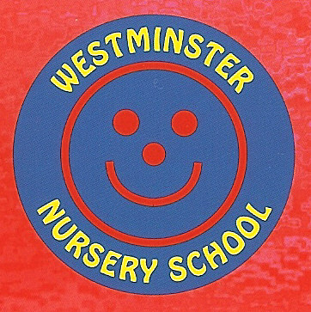

Early Years Pupil Premium (EYPP)
Three and four year olds attending Westminster Nursery School will be able to get Early Years Pupil Premium funding if they meet at least one of the following criteria:
- their family gets 1 of the following:
  - Income Support
  - income-based Jobseeker's Allowance
  - income-related Employment and Support Allowance
  - support under part VI of the Immigration and Asylum Act 1999
  - the guaranteed element of State Pension Credit
  - Child Tax Credit (provided they're not also entitled to Working Tax Credit and have an annual gross income of no more than £16,190)
  - Working Tax Credit run-on, which is paid for 4 weeks after they stop qualifying for Working Tax Credit
  - Universal Credit
- they have been looked after for 1 day or more
- they have been adopted from care
- they have left care under a special guardianship order or residence order
Children with entitlement are awarded £0.53 per hour additional funding. This equates to £333.90 per EYPP eligible pupil over a full school year.
It is for each individual school to decide how the Pupil Premium is spent, since they are best placed to assess what additional provision should be made for the individual pupils within their responsibility. However, schools are to be held accountable for how they have used the additional funding to support pupils from low-income families.
Westminster nursery chooses how the EYPP is spent after reviewing the individual needs of each child, in order to develop each child’s potential to the maximum.

2021-22 Autumn Term
In 2021-22 there are currently 8 children eligible for EYPP. This equates to £333.90 per pupil for the whole of the school year. The money is to be spent as per the following table, and impact will be monitored through data and well-being. For this term it equates to £111.30 per pupil.

2022-22 - Main Barriers to Achievement for EYPP Eligible Pupils
- Speech and Language – Delayed language development, impact of EAL, all aspects of CL, most particularly speaking, listening attention and understanding. Use of SALT plans with individual children. Extending communication for more able.
- Managing Self – Support with toilet training, to be independent with clothes such as coats and to gain confidence in social situations - self –confidence building activities, nurture group and KW support.
- Reading – development of language and low-level book skills, lack of English provides a barrier.
- Building Relationships – Ensuring engagement with others and ability to develop relationships including understanding of feelings. Developing confidence in play. This links across all areas of development. This area includes our nurture, self-confidence groups.
- Home development – links with behaviour management and parenting strategies for children who are challenging at home.

Project | Cost Breakdown | Cost | Impact | Notes
Nurture Group/Building Relationships  EYPP child to have targeted group work and activities to support with nurture around their emotional needs and understanding emotions. | 1/2 Hour per week of TA time  All EYPP children requiring nurture and circle time support – TA Support  Equipment bought to support this area | £113.12 | Children’s well- being is improved, confidence is raised  In class time support given to specific children  Understanding of emotions promoted | Key worker knowledge shows improvement  Pupil Progress meetings
Speech and Language  SALT plans and additional WELLCOMM groups | TA time 0.3 hours per week | £452.48 | Speech monitored from baseline, regularly to track progress  Extend and challenge at appropriate level to ensure highest outcomes for all.  WELLCOMM levels raised | Pupil progress meetings  Charts of interventions kept
Reading development of language and low-level book skills, lack of English provides a barrier | KW time | £50.40 | Child is able to understand and benefit from sharing and reading books with an adult support. Language development seen. | EYFS data  KW knowledge and daily 1:1 story
Managing Self  Children are supported by key workers to develop skills of independence including clothes, confidence building and toilet training. | Daily activities in KW groups | 282.80 | Children join in with group activities as understanding and listening/attention improve. | Overall levels improve across all subjects. Children’s self-esteem and self-confidence is improved.
Date of Next Review - Spring Term 2022

